

**CPE 112 Computer Programming**

**Pool Villa Booking System**

**Members**

Kawinpob Amnuaywittayakul 67070503403

Pawarut Kumnungwut 67070503422

Phureeruch Satithangkul 67070503471

**Table of Contents**

Abstract 3

Introduction 4

Objective 4

Solution with Functionalities 4

Code Walkthrough with Data Structures 5

Time Complexity Analysis 9

Challenges and Solutions 10

Conclusion 11

Team Member Responsibilities 12

# 

# Abstract

This project presents a terminal-based Pool Villa Booking System developed in the C programming language. The system is designed to serve two types of users: customers and property managers. Customers can browse and book villas, view detailed property information, manage favorites, and cancel bookings with an automatic refund policy. Managers are provided with tools to add, edit, and remove villa listings, as well as to manage date-specific availability through an interactive calendar interface. Data persistence is handled through CSV files, ensuring ease of storage, portability, and simplicity in editing. The system includes robust date validation and conflict checking to prevent overlapping bookings and maintain accurate records. By leveraging structured data, user role separation, and clear console-based interactions, the system aims to streamline the pool villa rental process while maintaining reliability, usability, and scalability for future extensions.

# Introduction

This system is designed to simplify the process of booking pool villas for customers and streamline villa management tasks for property managers. Customers can browse available villas, view detailed information, make bookings, manage favorites, and cancel reservations with automatic refunds. Managers are provided with tools to add, edit, or delete villa listings, control calendar availability, and review booking history. The system uses a terminal-based interface developed in the C programming language, with all data stored in CSV files for easy management and portability. Calendar-based availability and booking validation help prevent double-bookings and ensure an accurate schedule. The goal is to provide a complete, efficient booking experience with a user-friendly interface and a reliable back-end.

# Objective

The objective of this project is to develop a comprehensive booking and management system for pool villas, enabling both customers and property managers to efficiently interact with the system. For managers, the system offers features such as viewing and managing villa listings, performing CRUD operations on property data, setting calendar availability, blocking dates for maintenance, and reviewing booking and cancellation histories. Customers can browse available villas, view detailed information, add favorites, make bookings for specific dates, and cancel bookings with an automatic refund policy. The system also includes a calendar-based availability interface to prevent overlapping bookings and ensure smooth scheduling. All data is stored and updated using CSV files, ensuring easy management and future scalability of the platform.

# Solution with Functionalities

This Pool Villa Booking System addresses the challenges of managing short-term villa rentals through a clear separation of roles and features. It provides a robust console-based interface backed by structured CSV data storage and dynamic memory management using C.

**Customer Side Features:**

* **Browse Villas:** View a list of all available villas with basic details like price, location, and rating.
* **View Details:** Access full information such as address, facilities, transportation, and nearby landmarks for any villa.
* **Book a Villa:** Select check-in and check-out dates. The system validates availability using Calendar.csv and confirms booking.
* **Cancel Booking:** Customers can cancel bookings and receive a 90% refund. Cancellations are logged in Cancelled_bookings.csv.
* **Manage Favorites:** Add or remove favorite villas to favorites.csv and view the list later.
* **Calendar Availability View:** A monthly calendar grid highlights available, booked, and blocked days visually for easy booking decisions.

**Manager Side Features:**

* **Add/Edit/Delete Villas:** Manage property records using Briefly_Info.csv and Detail.csv with full CRUD functionality.
* **Set Calendar Availability:** Use a calendar UI to block/unblock dates or mark them for maintenance in Calendar.csv.
* **Booking History:** Access full logs of past bookings from Booking_history.csv.
* **Override Calendar:** Managers can override availability for urgent maintenance or special bookings.

# Code Walkthrough with Data Structures

This project is built in the C programming language using a modular design. It utilizes structured data (struct), dynamic memory (linked list), 2D arrays (for calendar rendering), and CSV file I/O for persistent storage. The system separates features between customers and managers, each backed by clearly defined data structures.

**1. Struct Definitions**

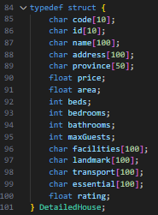Stores full villa information loaded from Detail.csv.

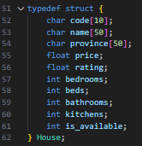Used to store and display summarized villa data from Briefly_Info.csv.

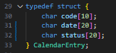Represents date-specific availability loaded from Calendar.csv.

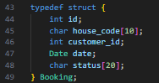Stores a customer's booking information, written to Booking_history.csv.

Used internally for booking and availability logic, easier for date comparisons.

**2. Linked Lists**

**Linked lists** are used to dynamically manage data such as:

* Houses (for loading and displaying villa listings)
* Favorites (customer-selected villas)
* Bookings (when viewing history or filtering)

Reason why Linked Lists

* No need to predefine size like arrays
* Efficient insert/delete operations
* Suitable for filtering, dynamic loading, and handling user-specific lists

This allows the system to:

* Load villas into memory from CSV
* Display filtered search results
* Manage changing sets of favorites or bookings efficiently

**3. Calendar Grid (2D Array)**

* Renders the availability of each villa per month
* Visually displays [ ] = Available, [X] = Booked, [B] = Blocked

Visual terminal-based monthly calendar UI helps customers/managers see availability status day-by-day.

**4. CSV File Integration**

All persistent data is stored and read using .csv files. The format allows easy portability, editing, and long-term data handling.

* **Briefly_Info.csv, Detail.csv** – Store summarized and detailed house records respectively.
  + Briefly_Info.csv: Used for list view and searching.
  + Detail.csv: Used for full property details on the booking page.
* **Calendar.csv** – Tracks **daily availability** of each house, including status: Available, Booked, or Blocked.
* **Booking_history.csv, Cancelled_bookings.csv** – Log all **confirmed bookings** and **cancellations with refund** for traceability.
* **favorites.csv** – Stores a list of **customer-selected favorite villas**, referenced by house codes.

**5. Flowcharts**

**Manager part:**

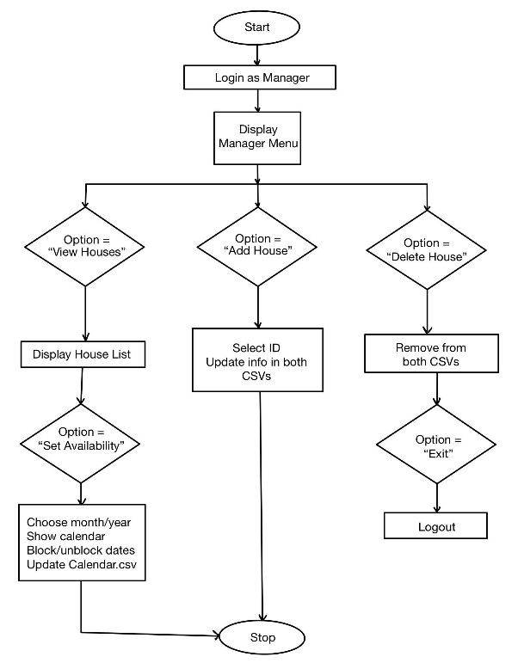

**Customer part:**

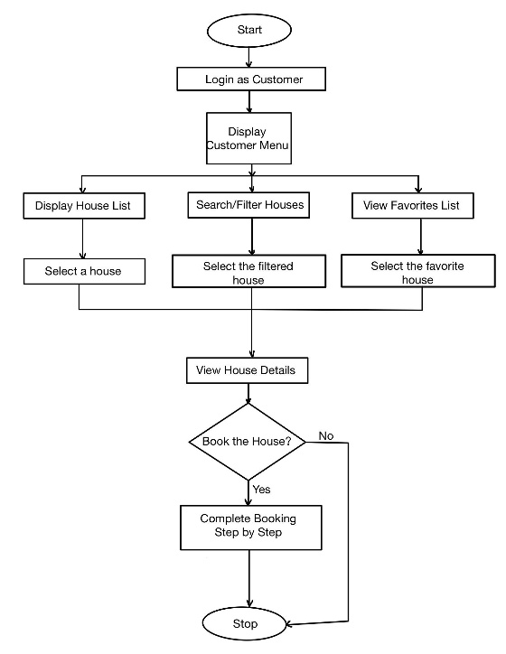

# Time Complexity Analysis

|  |  |  |  |
| --- | --- | --- | --- |
| **Operation** | **Best Case** | **Worst Case** | **Data Structure** |
| Search villa by code/name | O(1) | O(n) | Linked List / CSV |
| Add/Edit/Delete villa | O(1) | O(n) | Linked List |
| Booking conflict check | O(1) | O(d) | Calendar file (CSV) |
| Cancel booking | O(1) | O(n) | CSV line-by-line |
| Load/display calendar grid | O(1) | O(31) | 2D array rendering |
| Add/Remove from favorites | O(1) | O(n) | Favorites list (CSV) |
| Read/Write to CSV | O(n) | O(n) | File operations |

This system relies on file-based storage (CSV files) and dynamic in-memory structures like linked lists and arrays. The performance of each operation depends on how many records must be processed.

* **Search villa by code/name**: Performed linearly through a list or CSV file. Best case is O(1) if the villa is found early. Worst case O(n) when it's the last entry or not found.
* **Add/Edit/Delete villa**: In a linked list, adding a new villa at the head is O(1). However, editing or deleting requires traversal to find the target node, leading to O(n) in the worst case.
* **Booking conflict check**: When a user selects check-in and check-out dates, the system scans Calendar.csv for any overlap. Checking just a few days (e.g., a weekend stay) is fast—O(1) to O(3)—but longer date ranges increase complexity linearly with the number of days, hence O(d).
* **Cancel booking**: Searches for a matching record in the booking history file. If the record is early, it's fast (O(1)), but if it's deep in the file, it may take O(n) time.
* **Load/display calendar**: Rendering the calendar for a month always processes 28 to 31 days, which is a small, fixed size. Thus, this operation is effectively O(1) in practice and at worst O(31).
* **Favorites management**: Add/remove favorites works with a small list stored in a flat CSV file. It requires a linear search (O(n)) to prevent duplicates or remove a match.
* **Read/Write to CSV**: Every read or write operation processes full files line by line. Since there's no database or indexing, it's always O(n) based on the number of lines in the file.

# Challenges and Solutions

**Data Consistency Across Multiple Files**  
In some cases, house or calendar data is saved across multiple CSV files such as Briefly_Info.csv, Detail.csv, and Calendar.csv. This creates confusion when one item is edited, as the same house must be updated in all files. The solution to this is to create a logic that synchronizes changes across files using temporary storage and rewriting the files together.

**Booking Conflict and Calendar Overlap**  
When a customer tries to book a house, the system must make sure that the dates are not already booked or blocked by the manager. The problem is checking overlapping dates from the calendar file. The solution to this is to use a linked list to load all the dates and check every entry during booking.

**Displaying a Visual Calendar in Terminal**  
Creating a monthly calendar view in the terminal that matches real-world layout (starting on the right weekday) is difficult. The solution to this is using the built-in time functions and creating a 2D array to print the dates correctly in a grid format.

**Difference in Variables due to Miscommunication**  
When coding separately, a problem occurred where the variables used in different functions did not match. This caused compile-time errors and wrong data assignments. The solution to this is to communicate clearly and unify all struct definitions and variable names used by all members.

**Editing Two of the Same Item in Multiple CSV Files**  
Sometimes a house name or ID appears in more than one CSV file. When one is edited, the other still has the old value, which causes inconsistency. The solution to this issue is creating a temporary variable or file to remember the original name and use it to update all other CSV files.

**Managing Favorites and Booking History Without a Database**  
Since this project uses only CSV files and no database, keeping track of customer favorites and booking history is hard. The solution to this is using linked lists to load data into memory, then writing back to CSV after any changes.

# Conclusion

The Pool Villa Booking System was successfully developed using C, with features supporting both customers and managers. Key functions like booking, cancellation, calendar availability, and house management were implemented with structured logic and CSV file handling. Challenges such as keeping data consistent across files and handling input validation were solved with proper planning and clear communication. Overall, the system meets its goals and demonstrates practical file-based data management and user interaction in C.

# Team Member Responsibilities

|  |  |  |
| --- | --- | --- |
| **Name** | **Student ID** | **Role & Responsibility** |
| **Pawarut Kumnungwut** | 67070503422 | Responsible for all **Manager-side functionalities**, including villa CRUD operations and calendar availability setup. |
| **Kawinpob Amnuaywittayakul** | 67070503403 | Developed **Customer-side features**, including villa browsing, booking, favorites management, and cancellation system. |
| **Phureeruch Satithangkul** | 67070503471 | Overseeing the overall system design, workflow coordination, and implementing all **CSV file handling and integration**. |